7-Day Trial Period Agreement

This 7-Day Trial Period Agreement (“Agreement”) is made and entered into by and between Custom Manufacturing & Engineering, Inc, an Florida corporation, (“CME”) and the undersigned as of the date set forth in the signature block of this Agreement (the “Effective Date”)
WHEREAS, the CME is engaged in the business of providing SiteLites; and
WHEREAS, the Customer desires to participate in CME's SiteLites Trial Period Program, on the following terms and conditions.
NOW, THEREFORE, for the mutual promises contained herein and for other good and valuable consideration set forth herein, the parties agree as follows:
- Trial Period Program. The CME shall

provide the SiteLites product(s) described in the Exhibit A attached hereto and incorporated herewith (each a “Product,” collectively the Products) to Customer for a period of 7 days commencing upon the date that the Product(s) is accepted by CME (“Trial Period Program”), unless terminated earlier in accordance with the provisions of this Agreement. Acceptance shall be deemed to occur upon the delivery and installation of the Product by the CME.

Delivery, Installation and Removal.
a. CME shall deliver the Product to Customer in the manner set forth in the Purchase Order, described in Section 3 below.
b. If a Customer wants to return any Product(s) prior to or at the conclusion of the Trial Period Program, Customer shall provide the CME written notice of Customer’s intention to terminate this Agreement, and CME shall schedule the return of the Product(s) in accordance with its business demands and available work force.

Purchase Order, Invoicing and Credit Card Information.
- In order to receive the Products, Customer
shall execute the Purchase Order prepared by CME in the form attached hereto as Exhibit B, which shall set forth the quantity of Product(s) described in Exhibit A, the amount of the sale price of the Product described in Exhibit A, any delivery charges and/or fees that may apply as outlined in the terms and conditions in the Purchase Order. Such Purchase Order shall contain valid credit card information that does not expire less than 90 days from the date of this Agreement.
- Upon receipt and acceptance of the executed purchase order, CME will schedule the delivery of the Products in accordance with its business demands and available work force.
- A security deposit will be charged to the amount of 75% of the chosen product’s listed price. This security deposit will be frozen on the given credit card in Exhibit B.

- The CME shall have the absolute right to charge the credit card contained in the Purchase Order for all amounts set forth in the Purchase Order (minus the security deposit) if
- CME shall have the absolute right to charge the credit card contained in the Purchase Order for all amounts set forth in the Purchase Order (minus the security deposit) if CME has not received written notice of Customer’s
- intention to have the Product(s) removed prior the termination of the Trial Period Program. For purposes of termination, the last day to terminate this Trial Period Program shall be by 11:59 p.m. EST on the 7th day following the date the Product(s) is accepted by Customer.
- Excessive Wear & Tear. If Product(s) returned to CME are damaged beyond normal wear & tear CME shall evaluate and determine what portion of the security deposit to retain, refund, and/or charge full.
- License for Use. CME grants to Customer
an exclusive, nontransferable, revocable right to use the Product(s) solely for the purpose of evaluation for possible purchase from the CME and only for the duration of the Trial Period Program. Customer shall not sublicense the right to use the Product(s) or transfer the Product(s) to a third party, doing so would be a breach of this agreement and subject to loss of security deposit and additional charges

Title to Products during Trial Period.
- Customer acknowledges and agrees that the CME is the owner or the authorized distributor of the Products(s) and except for
the right to use the Products as set forth below, Customer shall have no other right, title and/or interest in or to the Products. Customer shall not make any representation to the contrary.
Customer shall keep the Products at all times free and clear from all claims, levies, liens, process, security interest and encumbrances. Upon expiration or termination of the Trial Period that does not result in the purchase of the Product(s) by Customer, Customer, at its expense, shall return the Products to CME in the same condition in which the Products was received, ordinary wear and tear excepted.
- Customer shall not alter or modify the Product(s) in any way, including but not limited to: reverse engineering the Product(s) or disassembling the Product(s)

- Notwithstanding the above, should Customer choose to purchase the Product(s) from CME, terms and conditions for such purchase shall be made pursuant to the terms and conditions accompanying the Purchase Order in Exhibit B.
- In event of purchase of Products and/or return but one is damaged they cannot be repaired then title shall of Products transfer to Customer.
- Risk of Loss. Upon delivery of the Product(s) to Customer, all risk of loss, damage, theft or destruction, partial or complete, to any item of the Product(s) solely caused by the acts or omissions of Customer shall be borne by Customer. Customer shall promptly notify CME of any theft, loss or damage to the Product(s) and will be charged for the full value of the product.
- “AS IS” AND DISCLAIMER OF WARRANTY; LIMITATION OF LIABILTY. THE PRODUCT(S) PROVIDED BY CME “AS IS” AND CME HEREBY DISCLAIMS ALL WARRANTIES, WHETHER IMPLIED, EXPRESS OR STATUTORY, INCLUDING, WITHOUT LIMITATION, WARRANTY OF MERCHANTABILITY OR FITNESS FOR A PARTICULAR USE AND ALL WARRANTIES FOR TITLE AND NON-INFRINGEMENT. CME SHALL NOT BE LIABLE TO CUSTOMER FOR DIRECT, INDIRECT, SPECIAL, PUNITIVE, CONSEQUENTIAL OR INCIDENTAL LOSS OR DAMAGE (INCLUDING, BUT NOT LIMITED TO, LOST PROFITS, LOSS BY REASON OF SHUTDOWN IN OPERATION OR INCREASED EXPENSES OF OPERATION) OF ANY NATURE ARISING FROM ANY CAUSE WHATSOEVER, EVEN IF CME HAS BEEN ADVISED OF THE POSSIBILITY OF SUCH LOSSES OR DAMAGES. EXCEPT AS SET FORTH IN A PURCHASE AGREEMENT BETWEEN THE PARTIES, THE PROVISIONS OF THIS SECTION 7 SHALL SURVIVE THE EXPIRATION OR TERMINATION OF THIS AGREEMENT FOR ANY REASON.

Indemnity/Indemnification.
- Customer will indemnify, defend and hold CME harmless from and against any and all claims, actions, damages, liabilities, costs and expenses, including reasonable attorneys’ fees and expenses, arising out of or resulting from any bodily injury (including death) and/or damages to tangible property suffered by Customer and/or a third party to the extent proximately and proportionately caused by any willful misconduct or negligent act or omission of
- the Customer, its employees or agents, in connection with this Agreement.
- Customer hereby agrees to indemnity, defend, and hold harmless CME (and its successors and assigns, shareholders, directors, officers, agents, estate, heirs, personal representatives, and/or its employees) from and against any and all liabilities, expenses (including court costs and attorneys' fees
& costs) and claims for damages of any kind, whether known or unknown/direct or indirect which CME may incur, suffer, become liable for and/ or which may be asserted/claimed against CME as a result of acts, errors, omissions, negligence, and/or statutory violations by Customer. Additionally, statutory violations by Customer. Additionally, Customer shall indemnify, protect, defend, and hold- harmless CME from and/or against any Third-Party (including but not limited to Customer's use of SiteLites) from: claim, whether actual or threatened suit and/or proceeding(s)—whether civil/criminal/administrative/investigative, and/or all losses/ liabilities/damages and expenses(including but not limited to reasonable attorneys' fees and costs) in connection with this Agreement and/or services here-under.
- Customer shall carry all insurances and bonds necessary (such as but not limited to Workers Compensation) to cover themselves and their employees/consultants/temps/staff/contractors at no less than $1 million policy which covers their work and/or SiteLites (and use, set-up, transportation thereof, ect.). Proof of such should be submitted to CME at CME’s request; in the event that such is not submitted and/or coverage does not exist, or coverage ceases to exist then Customer shall solely liable and continue indemnification to CME as described above to the fullest extent of the law.
- Termination. Notwithstanding anything to the contrary contained herein, CME may terminate this Agreement and repossess the Product(s) immediately upon written notice if the Customer fails to adhere with any of the material terms of this Agreement, the Customer is adjudicated bankrupt, files a petition in bankruptcy, makes an assignment for the benefit of creditors or commences dissolution or liquidating proceedings.

- Wear and Tear. Customer specifically acknowledges that it will continue to use the Property of CME (during the trial) in the course of Customer's business and accepts the fact that reasonable wear and tear will occur after the date of this Agreement. Customer specifically agrees that CME is not responsible for repairing such reasonable wear and tear (after the term of this Agreement, unless Customer specifically requests CME repair such and Customer pays CME for such services) and that Customer is prohibited from raising such wear and tear as a reason for not consummating this transaction and/or for requesting a reduction in the Purchase Price. Additionally, wear & tear shall not constitute a defect as a reason under which not to fulfill the terms of this Agreement and/or constitutes a reason for breach of this Agreement.
- Independent Status. This Agreement shall not be considered or construed to be a partnership or joint venture, and the CME shall not be liable for any obligations incurred by Customer unless specifically authorized in writing. Customer shall not act as an agent of CME, ostensibly or otherwise, incur or hold liabilities for services under this agreement, nor bind CME in any manner, hold themselves out or permit themselves to be held out as having any authority to do or say anything on behalf of and/or in the name of the other Party.
- Non-Recruitment Covenant. Neither Party, during this Agreement and for a period of two (2) years immediately following, shall either directly and/or indirectly, recruit any of the other Party's employees. Any employees whom apply to any position which is open to the public shall not be considered a violation herein-unless it is directed to a specific individual and/or group of individuals of the Party.
- Return of Property. On termination of this Agreement and/or decision not to purchase then Customer shall immediately deliver to CME all property in its possession, and/or under its care and control, belonging to CME, including but not limited to, any: SiteLites, SiteLites products, SiteLites Accessories/Spares, cables, and/or other CME information/tangibles which Customer has control (both active & passive), possession (or should be in their possession), covered under this Agreement.
Failure to return and/or any damage beyond simple cosmetic (defined as normal wear & tear and/or simple scratch of paint) shall result in forfeiture of security deposit to CME and/or result in charge for up to the full purchase price (security deposit).
- Notices. Any notice to be given here-under by any Party to the other may be affected either by personal delivery in writing, or by mail, registered or certified, postage pre-paid with return receipt requested. Mailed notices shall be addressed to the parties at the address given by Customer on page 5, but each party may change their address by written notice in accordance with this paragraph. Customer agrees to keep CME current as to their business and mailing addresses, as well as telephone, facsimile, e- mail and mobile numbers. Notices delivered personally shall be deemed communicated as of the actual receipt date.
- Attorneys' Fees & Costs. If any action at law or in equity is necessary to enforce or interpret the terms of this Agreement, each Party shall bear their own attorneys' fees and legal costs/expenses. And that neither party shall recover their attorneys’ fees and legal costs/expenses (unless otherwise specified in this Agreement including but not limited to indemnity), even if provided for by law.
- Arbitration. Any controversy between the Parties to this Agreement involving the construction or application of any of the terms, provisions, or conditions of this Agreement, shall on written request of either Party served on the other, be submitted first to mediation and then if still unresolved to binding arbitration; unless such action as equity requires or permanent/temporary injunction is required, both Parties further agree that any injunction shall not require the posting of a bond. Said mediation or binding arbitration shall comply with and be
governed by the provisions of the American Arbitration Association for Commercial Disputes unless the Parties stipulate otherwise in writing and the UCC (Uniform Commercial Code) shall not apply. Each side shall bear its own attorneys' fees and costs; as for the costs of arbitration shall be borne equally by the Parties. Arbiter shall not award attorneys' fees and costs to the winning Party even if provided for by law, however the winning party shall be entitled to recover damages as well as fees for the arbitration (location fees and cost + fees of the arbiter(s) if a

decision is rendered in their favor nor joint award
decision (awarding each Party some damages)).
- Damages Exclusion. Except for breaches of payment to CME and/or failure to Return Property to CME shall either Party be liable under this Agreement to the other Party for any incidental, consequential, indirect, special or exemplary damages, including but not limited damages from loss of profits and/or opportunities as well as procurement of substitute goods and/or services even if informed in advance of the possibility of such damages (except where SiteLites, SiteLites products, and/or SiteLites accessories are not returned to CME and/or are damaged beyond normal wear & tear as defined in Return of Property provision herein) under any strict liability/negligence/other legal or equitable theory. Additionally it is understood that the Parties' confidentiality and indemnification obligations here-under shall not be limited in any way by the aforementioned exclusion of damages. The limitations and exclusions set forth in this provision are an express part of the bargain between the Parties and the basis for fees charged herein.
- Representation. Each Party of this Agreement acknowledges that no representations, inducements, promises or agreements, orally or otherwise, have been made by any Party hereto, or anyone acting on behalf of any party hereto, which are not embodied herein, and that no other agreement, statement or promise not contained in this Agreement shall be valid or binding. Any modification of this Agreement shall be effective only if it is in writing, signed and dated by all parties hereto.
- Partial Invalidity. If any provision of this Agreement is held by a Court of competent jurisdiction to be invalid, void or unenforceable, the remaining provisions shall nevertheless continue in full force and effect without being impaired or invalidated in any way.

Governing Law; Exclusive Jurisdiction. This
Agreement shall be governed by, and construed under, the laws of the State of Florida (the Uniform Commercial Code/UCC or provisions adopted by Florida shall not apply nor shall the UN Connection of Contracts apply). Exclusive jurisdiction and venue for all purposes shall be in the Hillsborough County of the State of Florida.

Post-trial Interview and Photoshoot.
Customer agrees to complete a post-trial interview and photoshoot at the location of their business. The
interview and photoshoot together will have appropriate maximum duration of an hour. The Customer must have one person available for the photoshoot who can be identified, comments to such, and comments to CME’s use of any pictures and/or videos taken during them. All lighting and camera equipment required for the photoshoot will be provided and used by a Custom Manufacturing & Engineering Employee(s). The Customer will detail below the time and day the Interview and photoshoot will take place within one week of the purchase and/or use of the product.

Gift Card
Customer will receive a visa gift card totaling the amount of $20 after completion of their post-trial interview and photoshoot, in addition to their trial product(s) being returned. This gift card will be mailed to their business address, which will be written in the "Address" field below.
24. Continuing Guaranty. THIS IS A GENERAL GUARANTY WHICH IS ENFORCEABLE BY CUSTOM MANUFACTURING & ENGINEERING, ITS SUCCESSORS AND ASSIGNS (or his/her/their heirs and assigns). THIS IS ALSO AN ABSOLUTE AND UNCONDITIONAL GUARANTY. The undersigned (each a "Guarantor"), jointly and severally (if more than one), absolutely and unconditionally guarantee the prompt payment to Lender, including its successors and assignees, of any and all Obligations incurred by the Borrower pursuant to the Agreement (this "Personal Guaranty"). Each Guarantor further agrees to repay the Obligations on demand, without requiring Lender first to enforce payment against Borrower. This is a guarantee of payment and not of collection. This is an absolute, unconditional, primary, and continuing obligation and will remain in full force and effect until the first to occur of the following: (a) all of the Obligations have been indefeasibly paid in full, and Lender has terminated this Personal Guaranty, or (b) 30 days after the date on which written notice of revocation is actually received and accepted by Lender. No revocation will affect: (i) the then existing liabilities of the revoking Guarantor under this Personal Guaranty; (ii) Obligations created, contracted, assumed, acquired or incurred prior to the effective date of such revocation; (iii) Obligations created, contracted, assumed, acquired or incurred after the effective date of such revocation pursuant to any agreement entered into or commitment obtained prior to the effective date of such revocation; or (iv) any Obligations then or thereafter arising under the agreements or instruments then in effect and then evidencing the Obligations. Each Guarantor represents and warrants that it is a legal resident of the United States of America. Each Guarantor waives all notices to which the Guarantor might otherwise be entitled by law, and also waives all defenses, legal equitable, otherwise available to the Guarantor. This Personal Guaranty shall be construed in accordance with the laws of the State of Florida, and shall inure to the benefit of Lender, its successors and assigns. To the extent not prohibited by applicable law, each of the undersigned Guarantors waives its right to a trial by jury of any claim or cause of action based upon, arising out of or related to this guaranty, the Agreement and all other documentation evidencing the Obligations, in any legal action or proceeding.

CME:

By: Michael Crews, General Counsel

CUSTOMER:

Signature

Printed Name, Title

Address

City, State, Zip Code

Date

Email

Phone

I do not want to be contacted with the latest news and offers from Custom Manufacturing & Engineering

POST-TRIAL ACTIVITIES:

Date

Time

Exhibit A: Products

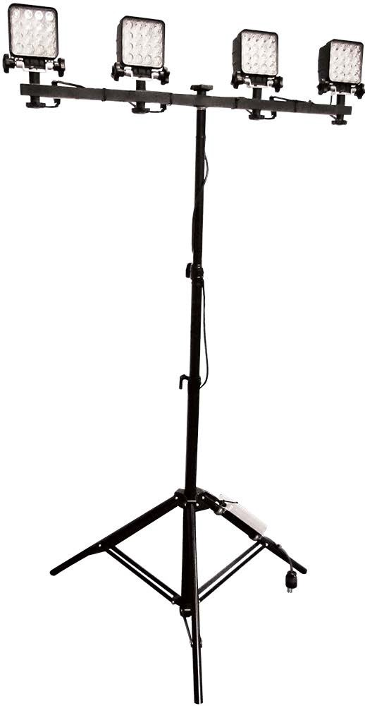SiteLites- Quad Work Light (SL12KT)
Light-weight temporary lighting, with four adjustable LED heads, providing 12,000 Lumens for any job-site lighting needs!

Floods – 60 degree beam spread (SL12KT-F)

Spots – 30 degree beam spread (SL12KT-S)

Hybrid – 30 and 60 degree beam spread LED heads (SL12KT-H)

Price: $420.00

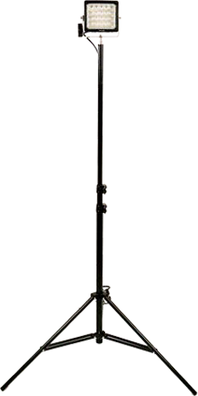SiteLites- Uni-Pod Work Light (SL9KT-H)

Light-weight temporary lighting, with one adjustable LED head, providing 9,000 Lumens for any job-site lighting needs!

Price: $325.00

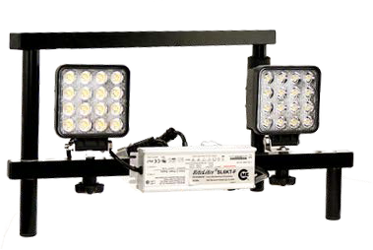SiteLites- Floor Work Light (SL6KF)

Light-weight temporary lighting, with two adjustable LED heads, providing 6,000 Lumens for any job-site lighting needs!

Floods – 60 degree beam spread (SL6KF-F)

Spots – 30 degree beam spread (SL6KF-S)

Price: $280.00

SiteLites- Magnetic Work Light (SL2KR-H)

Light-weight temporary lighting, with a magnetic base, providing 1,800 Lumens for any job-site lighting needs!

Price: $99.00

Exhibit B: Trial Order Form

DATE :
SHIPPING ADDRESS
NAME :
STREET ADDRESS :
APT #OR SUITE # :
CITY :
STATE
ZIP CODE:
CONTACT INFORMATION
NAME OF PERSON USING CREDIT CARD
CONTACT PHONE NUMBER :
E-MAIL ADDRESS :

CREDIT CARD INFORMATION
CREDIT CARD NUMBER :
EXPIRATION DATE :
CARD VERFICATION # :
BILLING ADDRESS
Same as Shipping Address

NAME ON CREDIT CARD :
STREET ADDRESS :
APT #OR SUITE # :
CITY :
STATE
ZIP CODE:

 | PART NUMBER | QTY | PRICE EACH | Security Deposit
ITEM |  | 1 |  | $

 |  |  | SUBTOTAL :
 |  |  | TAX : | 0 | Tax Exempt
 |  |  | SHIPPING : | 0
 |  |  | BILLED TO CARD :

